CSE 460: Software Analysis and Design

Directory Management System Phase I Submission

Directions:

Complete your work for Phase I Parts 1 and 2 in this document. Save and submit as a single​PDF titled “Last Name_First Name_Directory Management System Project_Phase I_Submission”.
Directory Management System Project Submission

Phase I, Part 1

Use the Astah tool to draw the class diagram for the current implementation of the university system. Use correct UML notations. When you have completed the diagram, take a clear screenshot and paste it in the space provided.

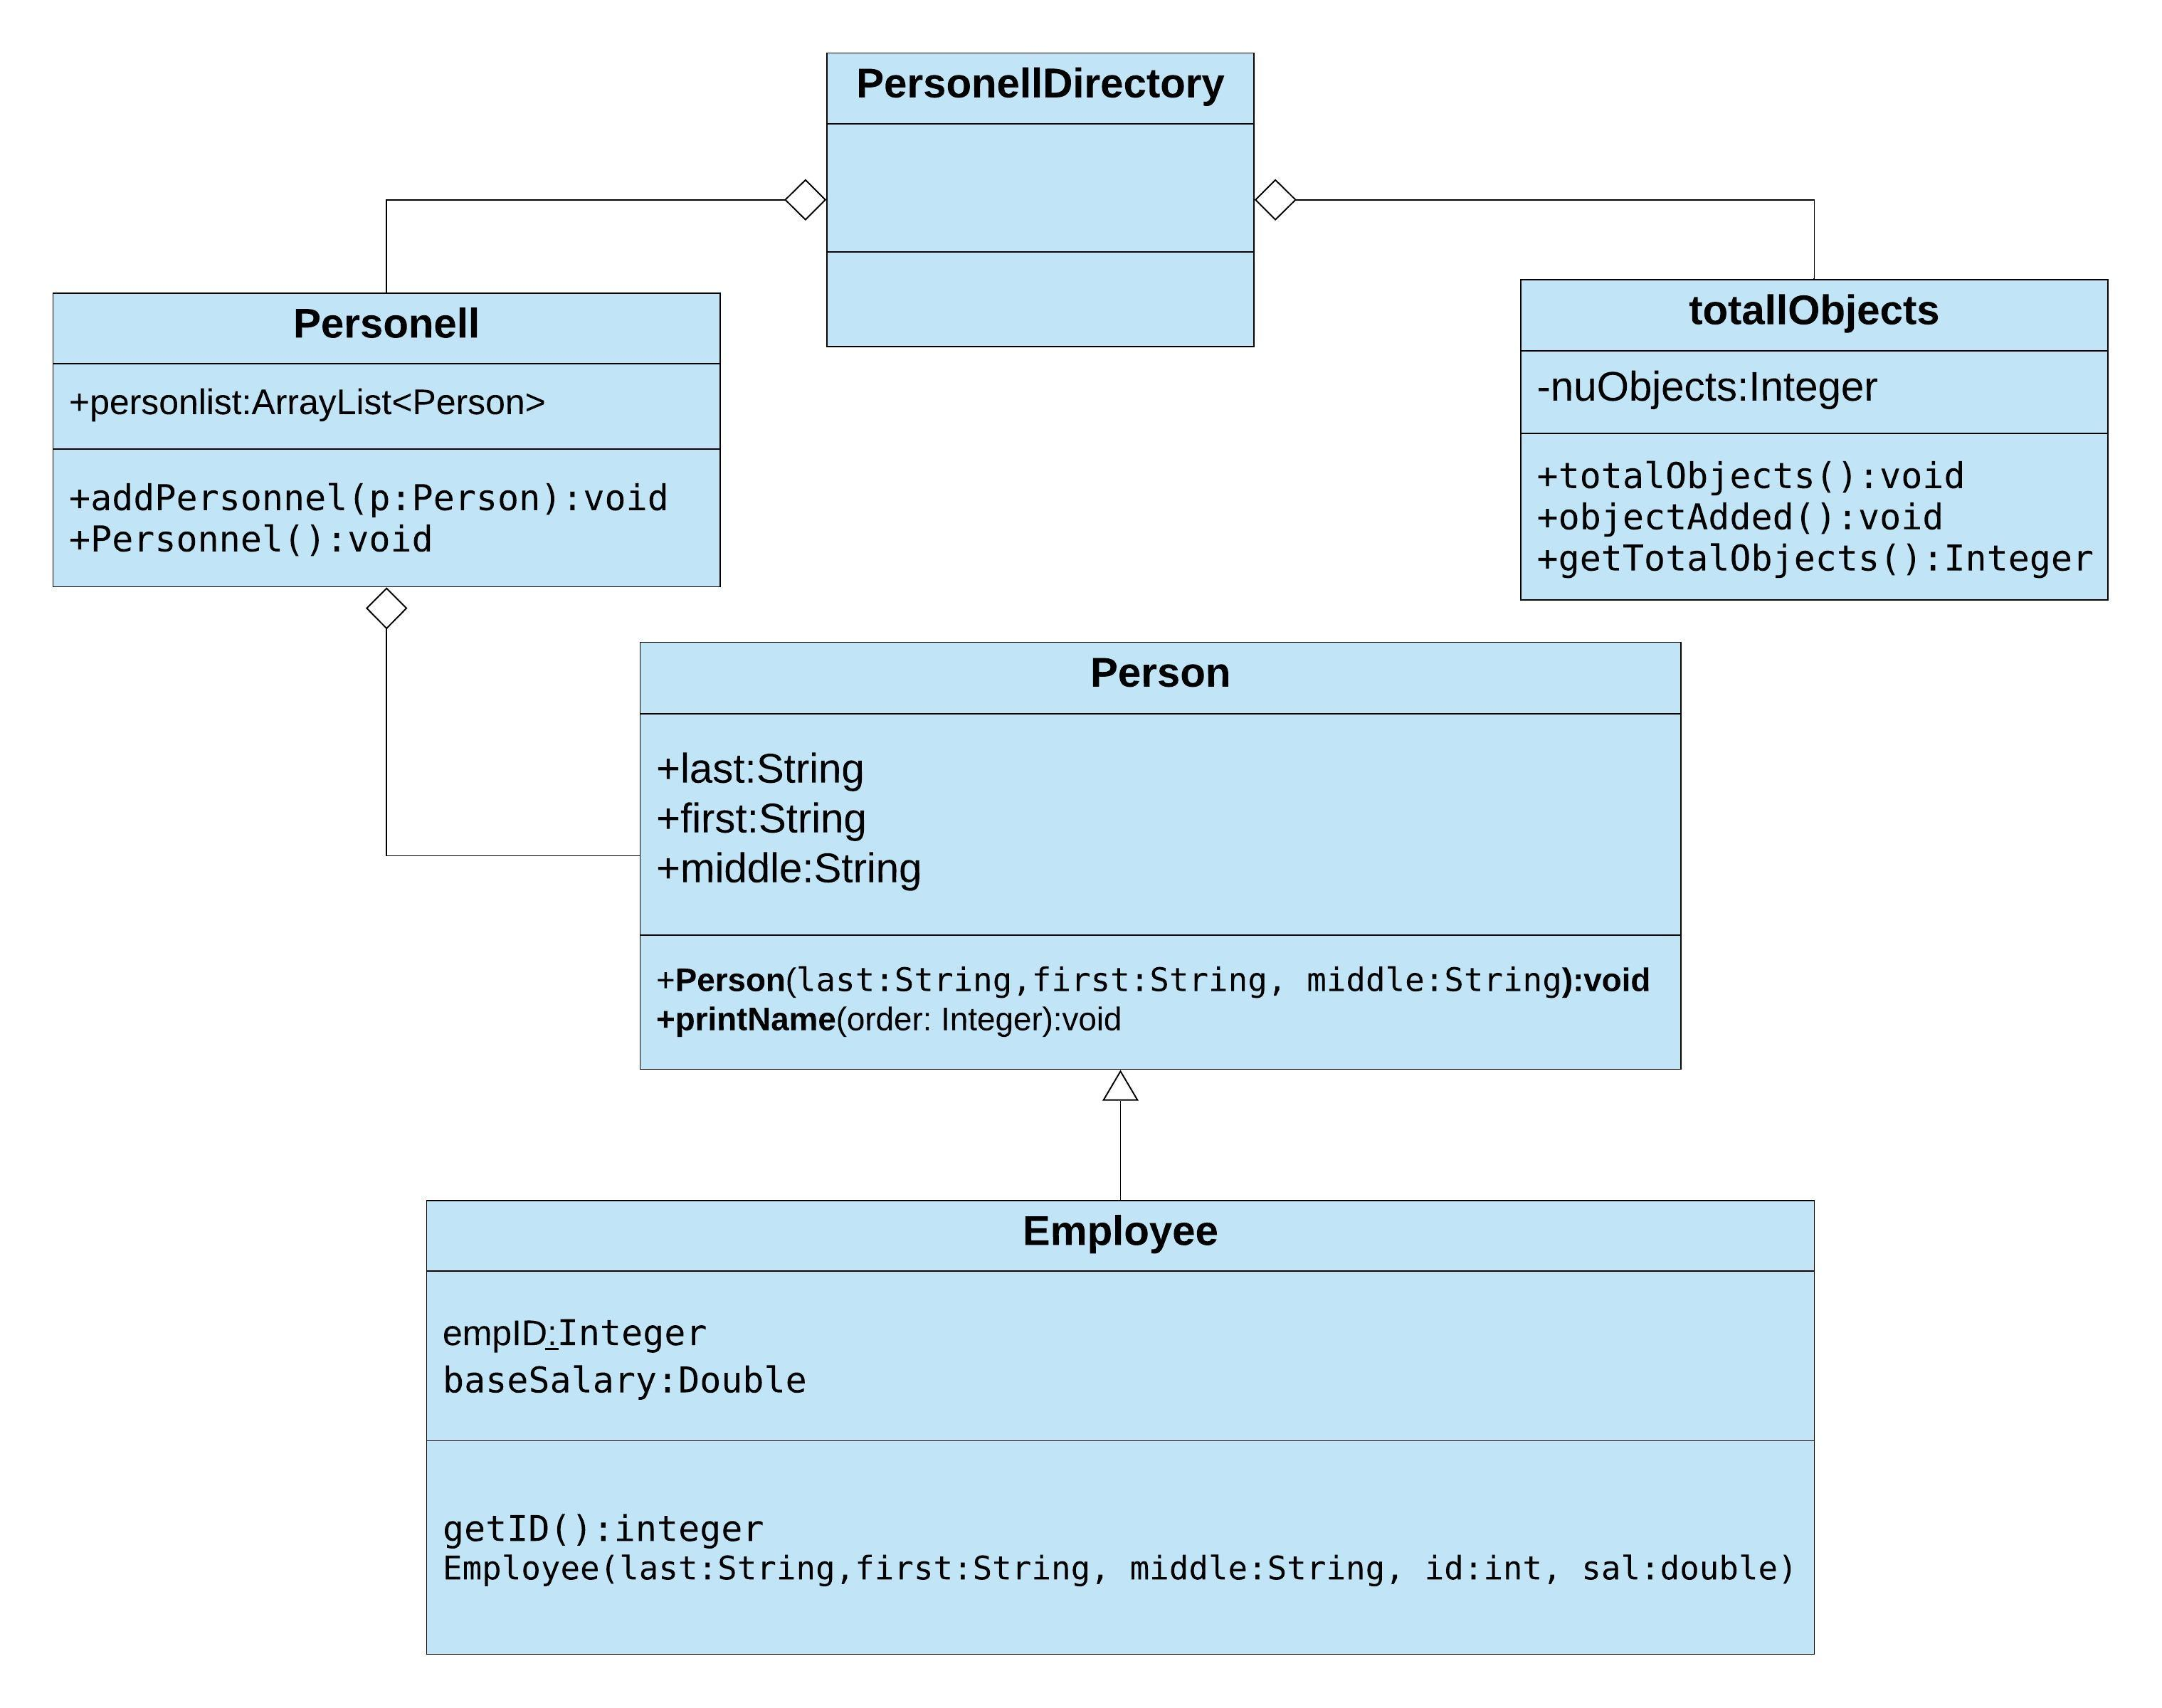
Directory Management System Project Submission

Phase I, Part 2

In the code, identify object-oriented concept violations, content coupling, common coupling, control coupling and stamp coupling situations. Copy and paste the code segments that shows each coupling situation in the space provided. ​You may use additional space as necessary.

- Object-Oriented Concept Violations

content coupling :
per.personList.add(p1);

Common Coupling
if( per.personList.get(i).first.equals(firstN) && per.personList.get(i).last.equals(lastN))

Control Coupling

per.personList.get(loc).printName(0);

public void printName(int order)
{
if(order == 0)
{
System.out.println(first + " " + middle + " " + last);
}else if(order == 1)
{
System.out.println(last + " ," + middle + " " + first);
}
else if(order == 2)
{
System.out.println(last + " ," + first + " " + middle);
}
}

Stamp Coupling
for(int i=0; i<per.personList.size(); i++)
{
per.personList.get(i).printName(order);
}

How would you fix these violations?
Content coupling: I would use the already inbuilt method for adding personnel to add a new personell

Common Coupling : use getters and setters to access the values of Person
Control Coupling : create other methos that can be called to print a specific option
Stamp Coupling :

- Content Coupling

per.personList.add(p1);

How would you fix this?

I would use the method addPersonnel(Person p) to access the personList

- Common Coupling

if( per.personList.get(i).first.equals(firstN) && per.personList.get(i).last.equals(lastN))

How would you fix this?

I would make the variables first and last in person private and use getters and setters to obtain their values. That is using data hiding

- Control Coupling
per.personList.get(loc).printName(0);

public void printName(int order)
{
if(order == 0)
{
System.out.println(first + " " + middle + " " + last);
}else if(order == 1)
{
System.out.println(last + " ," + middle + " " + first);
}
else if(order == 2)
{
System.out.println(last + " ," + first + " " + middle);
}
}

How would you fix this?

I would create methods that would do the same thing differently, one for each of the situations

- Stamp Coupling

for(int i=0; i<per.personList.size(); i++)
{
per.personList.get(i).printName(order);
}

